1. installing vi

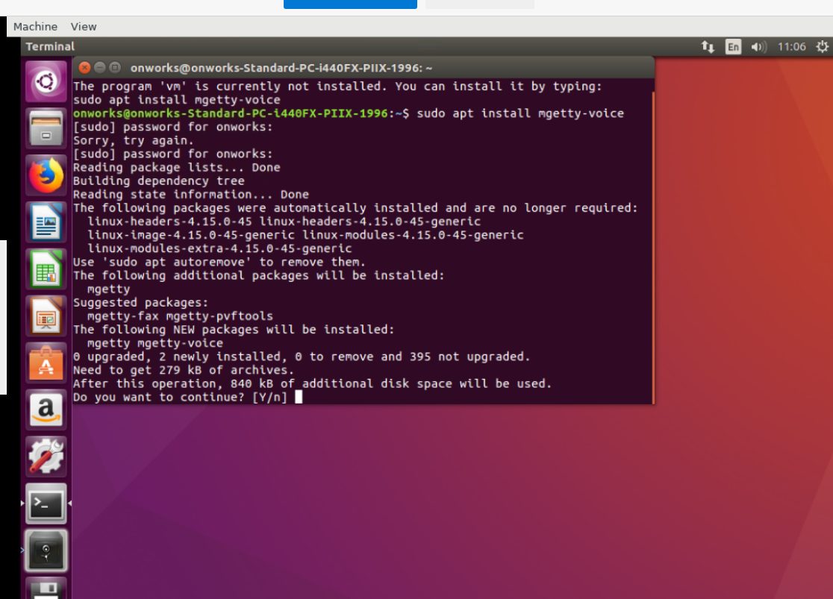

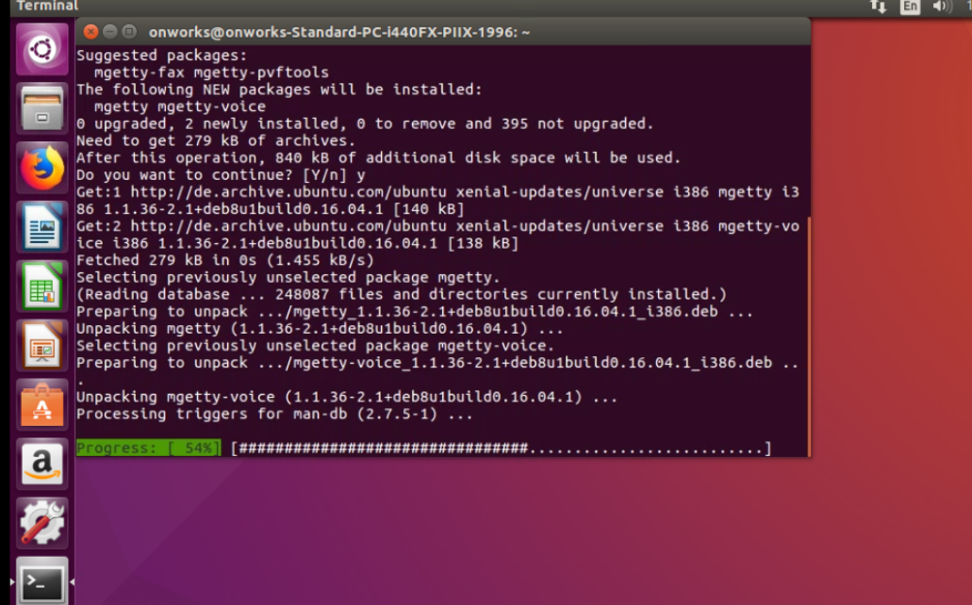

2. creating the directory --> pratiksha and the text file --> demo.txt

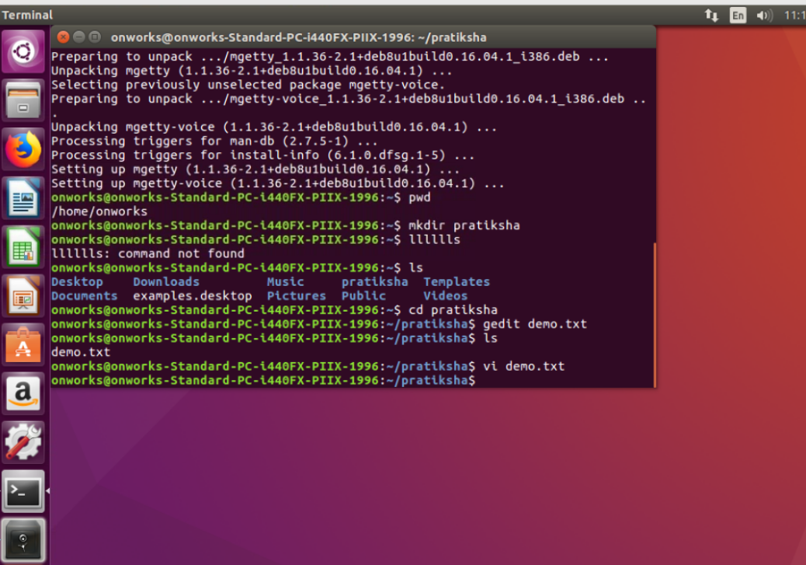

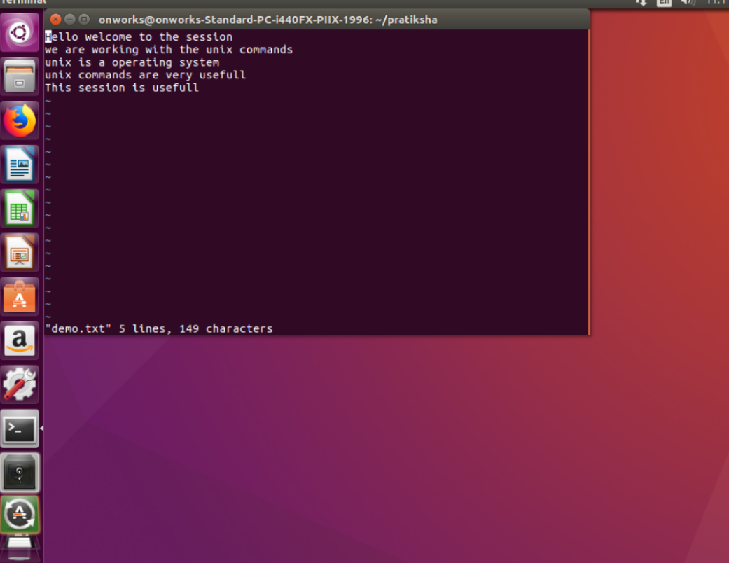

This is the content inside the demo.txt.

3.$head demo.txt: This will display first 10 lines

$tail demo.txt : This will display last 10 lines

$head –n 5 demo.txt: This will display starting 5 lines.

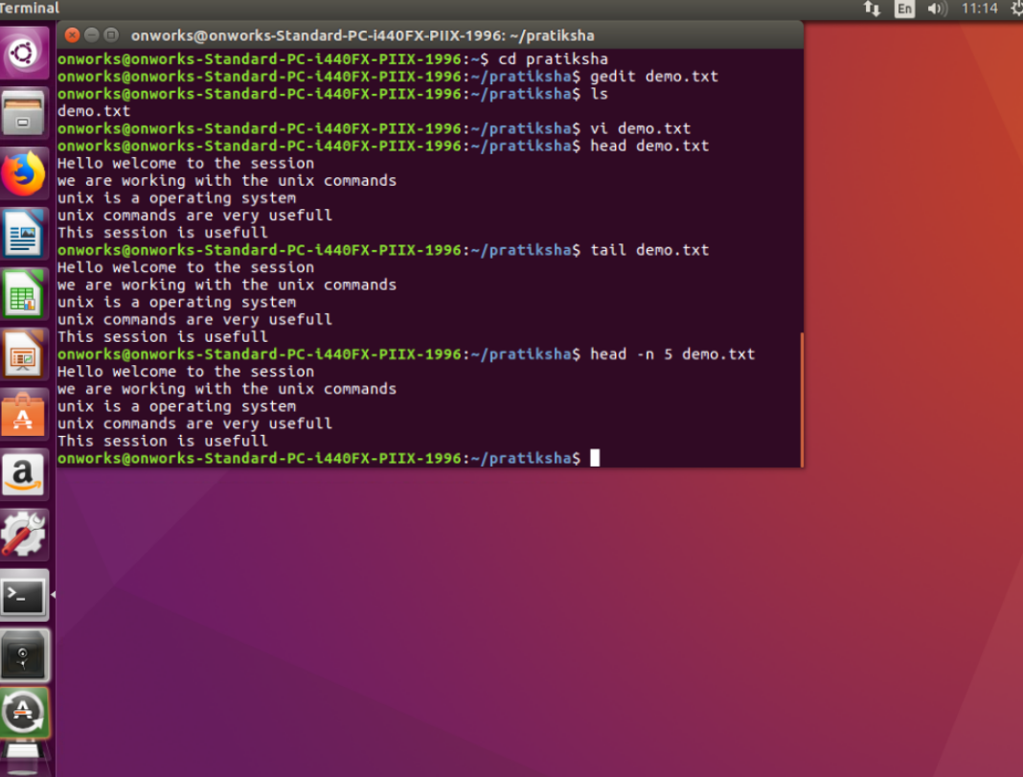

4. To copy the complete line, Place the cursor at the first word and press ‘yy’ and press ‘p’ to paste.

